[Test Plan] Belajar Bareng version 1.0

Document Status | Draft
Test Plan Creator | Fauzan Rizky Aditya
Test Plan Reviewer | - Muhammad  - Ganarya  - Nirwana

Introduction

Overview Feature to be tested
The belajar-bareng.onrender.com website is a web-based application that provides user authentication and data management features.

The features to be tested in this Test Plan include Login, Add User, Update, Delete, and Checkout.

Goals and Objective

The objective of this testing is to ensure that all core features of the system function correctly according to system requirements.

This testing also aims to validate system behavior when handling valid, invalid, or incomplete input, identify potential bugs or edge cases, and ensure proper error handling and system feedback are provided to users.

Test Item
List of test items (feature / product)

No | Feature | Test Item
1 | Login | - Login with valid credentials  - Login with invalid credentials  - Login with empty fields  - Login with special characters
2 | Add User | - Add a user with valid data  - Add a user with incomplete data  - Add a user with duplicate data
3 | Update | - Update data with valid  - Update data invalid input
4 | Delete | - Delete existing data  - Cancel delete action
5 | Checkout | - Checkout process

In Scope Testing
List of in feature to be tested

No | Feature | Requirement / Design specifications
1 | Login | 
2 | Add User | 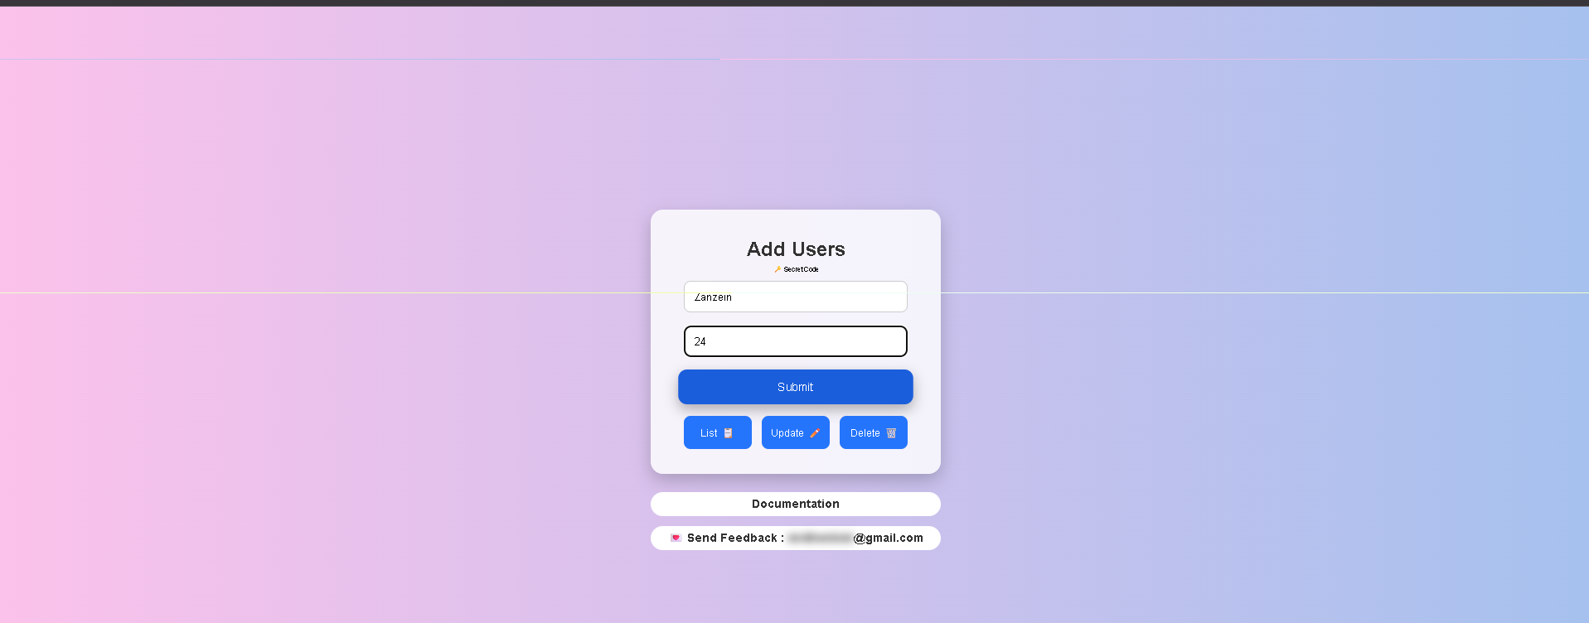
3 | Update | 
4 | Delete | 
5 | Checkout | 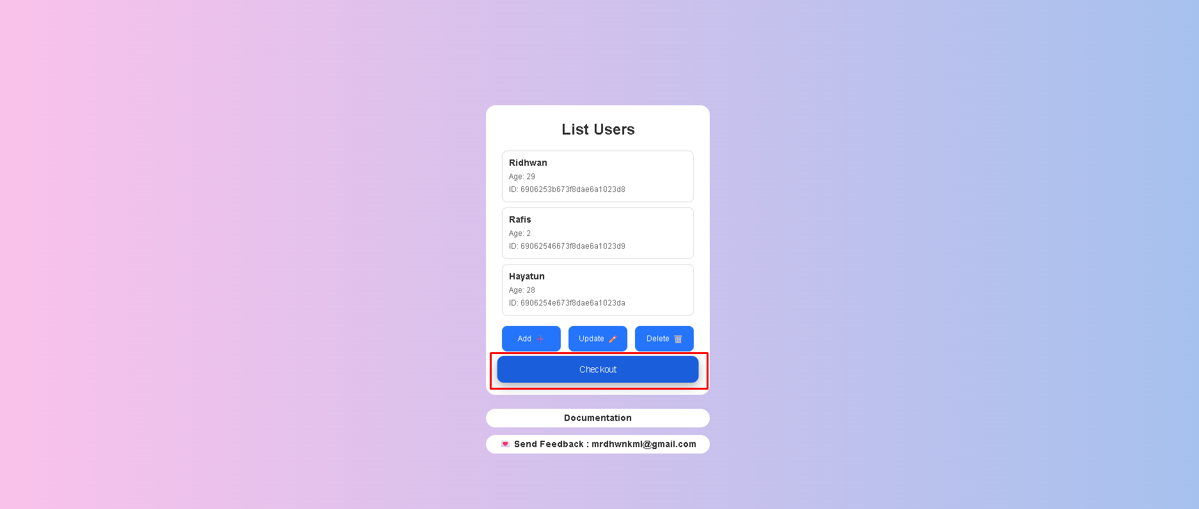

Out of Scope Testing
List the features of the software / product which will not be tested.

No | Feature | Reasons
1 | Register | User registration feature is not included in the testing scope.

Testing Approach
The testing approach used for the belajar-bareng.onrender.com website is manual testing with a combination of exploratory testing and test case–based testing.
Exploratory testing is conducted to understand the system behavior and identify potential issues by directly interacting with the application, especially because there is no detailed system documentation provided.
After the main features are understood, structured test cases are created based on the defined Test Items to validate the functionality of Login, Add User, Update, Delete, and Checkout features.
The testing focuses on functional testing, including validation of valid and invalid input, system responses, and error handling. All identified issues during the testing process are documented in the bug report.

Test Environment
The testing environment used during the testing phase is described as follows:
- Website URL: http://belajar-bareng.onrender.com/
- Application Type: Web Application
- Environment: Production
- Browser: Google Chrome
- Operating System: Windows 10
- Device: Laptop / PC
- Internet Connection: Stable internet connection

Test Deliverables
  - Test Plan: This
  - Test Case: (url)
  - Defect Report: (url)

Testing Timeline

No | Task | Estimation Time (Start Date) | Estimation Time (Finish Date) | Actual Time (Start Date) | Actual Time (Finish Date)
1 | Develop Test Planning | Jan 19, 2026 | Jan 20, 2026 | Jan 19, 2026 | Jan 20, 2026
2 | Develop Test Case | Jan 21, 2026 | Jan 23, 2026 | Jan 21, 2026 | Jan 24, 2026
3 | Test Case Review | Jan 24, 2026 | Jan 25, 2026 | Jan 25, 2026 | Jan 25, 2026
4 | Execute Test | Jan 26, 2026 | Jan 28, 2026 | Jan 26, 2026 | Jan 29, 2026
5 | Retest Bug | Jan 29, 2026 | Jan 31, 2026 | Jan 29, 2026 | Jan 31, 2026

References
List of related documents e.g PRD, Figma design, API Contract, Copy document etc

API Contract: https://swagger.io/belajar-bareng-api (Dummy Link)
Design: https://www.figma.com/file/belajar-bareng-ui (Dummy Link)

